Secure Coding Lab-1

Chekuri.mahesh

18BCN7101L39+L40

1. Create 10 files (txt, docx or any) and subfolders using your roll number followed by SS and numbering.

Commands & Output:

* 1. Creating subfolders:

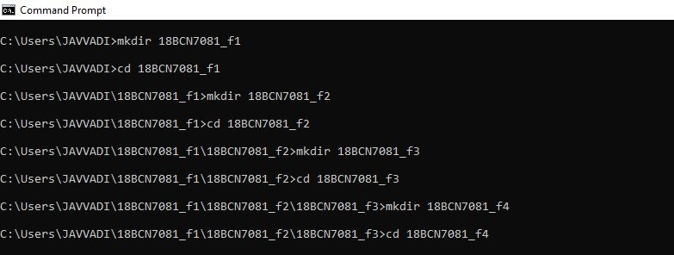

* 1. Creating Files in every subfolder:

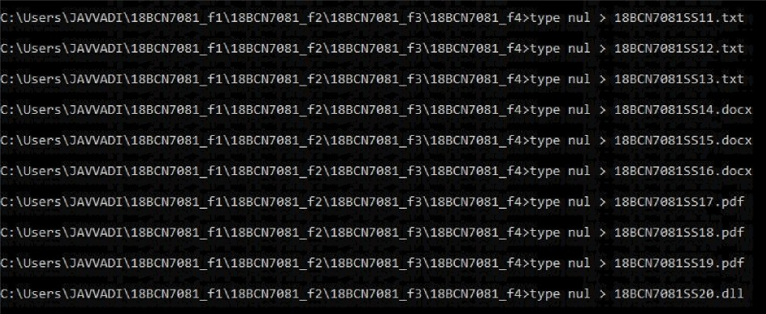

'C > Windows (C:) a Users 7 JAWADI r 18BCN70B1 f1 > 18BCN70B1 f2 > 18BCN70B1 f3 › 18BCN70B1 f4

Name

Date modified

Type

Size

|  |  |  |  |  |
| --- | --- | --- | --- | --- |
| B | 18BCN70B15511.txt | 22-02-2021 D9:Z2 | Text Document | 0 KB |
| B | 18BCN7081SS12.b‹t | 22-02-2021 09:22 | Text Document | 0 KB |
| B | 18BCN7081SS13.b‹t | 22-02-2021 09:22 | Text Document | 0 KB |
| B | 18BChI70B15514 docx | 22-0Z-Z0Z1 09:22 | DOCX File | 0 KB |
| B | 18BCN70B1SS15.docx | 22-02-20Z1 09:22 | DOCX File | 0 KB |
| B | 18BCN70B1SS16.docx | 22-02-2021 09:23 | DOCX File | 0 KB |
|  | 18BChI7081SS17.pdf | 22-02-2021 D9:23 | Adobe Acrobat D... | 0 KB |
|  | 18BCht70B1SS18.pdf | 22-02-2021 D9:2J | Adobe Acrobat D... | 0 KB |
|  | 18BCN70B1SS19.pdf | 22-02-2021 D9:23 | Adobe Acrobat D... | 0 KB |
| B | 18BCN7081S520.dll | 22-02-2021 09:23 | Application aten... | 0 KB |



T 3 Windows (C:) s Users 4 JAWADI 3 18BCN70B1 f1 s 18BCM70B1 f2 s 18BCN70B1 f3

Name

18BCht70B1 f4

B 18BCN7081SS01.doc B 18BCN70B1S502.doc B 18BCht70B1S503.doc

18BChI70815504.pdf

Date modified

Z2-02-2021 09:Z3 22-02-2021 D9:Z7

22-02-2021 09:27

22-02-2021 09:27

22-02-2021 09:Z7

Type

File folder DOCX File DOCX File DOCX File

Adob e Acrobat D...

Size

OKB 0 KB OKB OKB

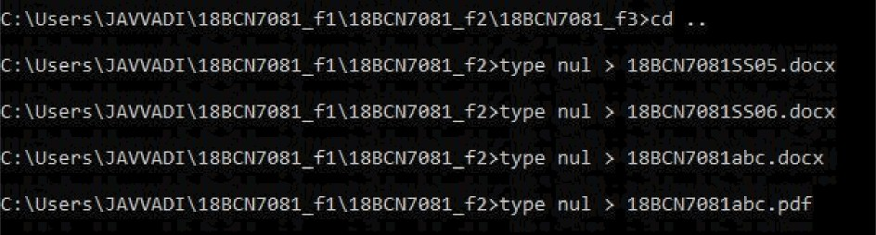

'C a Windows (C:) a Users a JAWADI 3 18BCN70B1 f1 > 18BCN70B1 f2

Name

18BCN70B1 f3

B 18BChI7081 abc.docx 18BCht70B1abc.pdf

B 18BCN70B1S505.doc B 18BCN7081SS06.doc

Date modified

22-02-2021 09:27

22-02-2021 D9:29

22-02-2021 D9:29

22-02-2021 D9:28

22-02-2021 09:28

Type

File folder DOCX File

Adobe Acrobat D... DOCX File

DOCX File

Size

0 KB

0 KB

0 KB

0 KB

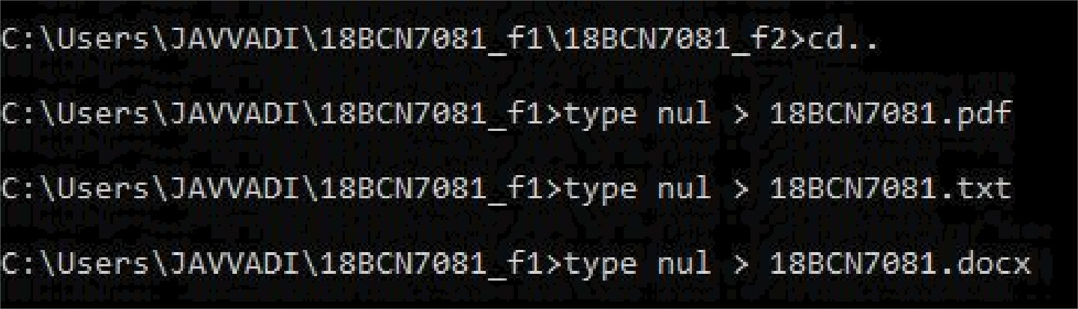

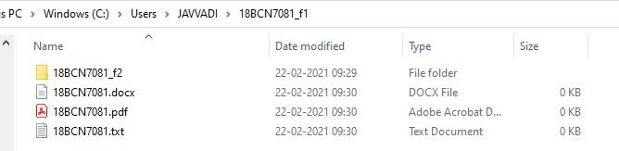

# Deleting all the files in folder 1.

Commands & Output:

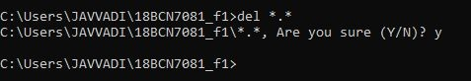

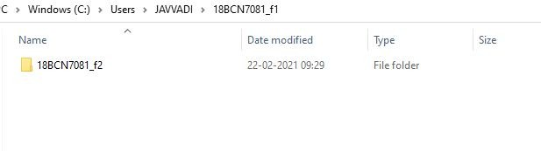

1. Deleting all the .docx files in folder 2.

Commands & Output:

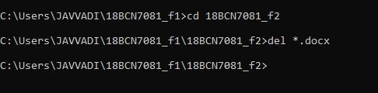

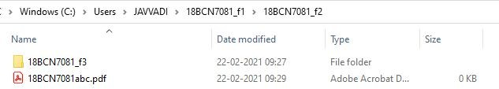

1. Deleting all the .docx files starting with SS in folder 3.

Commands & Output:

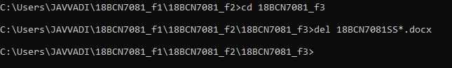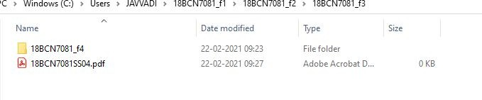

1. Deleting all the files from SS11 to SS20 in folder 4.

Commands & Output:



 